LINUX

Linux is an open source operating system . An operating System is a software that directly manages a system hardware & resources like, CPU, Memory and storage.

Command Line

The command line is a direct access to your computer by these users are allow to ask software to perform hardware action that simple point and click GUI can not perform.

Linux Basic Commands

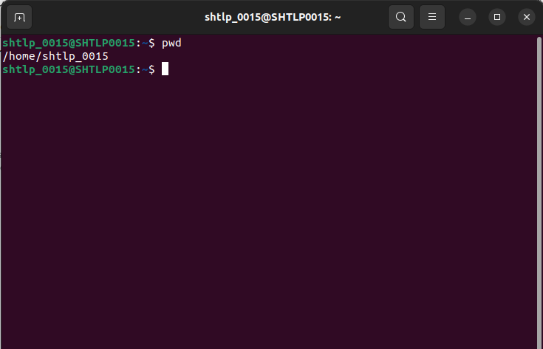
1. pwd- Print Work Directory . It print the current path of working directory , starting from the root.

2. cd : to change to current working directory
cd .. : to move to the parent of current directory

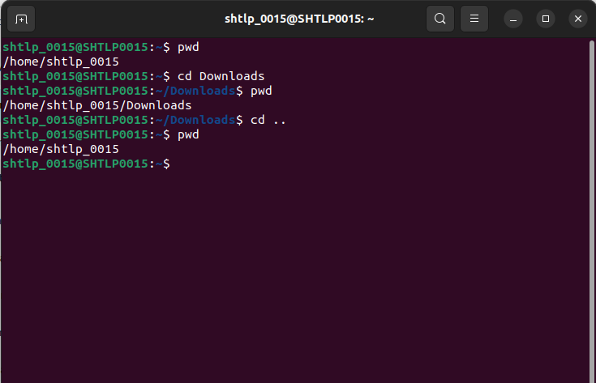
.
3. ls : list all the files present in the current directory..
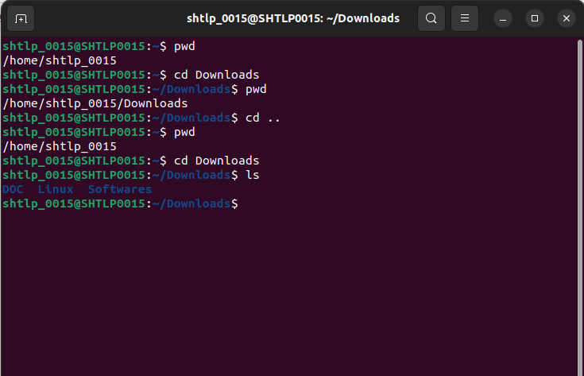
.

ls -a: list all files and directories including hidden files, in current directory
ls -al: it also give detailed information about each file

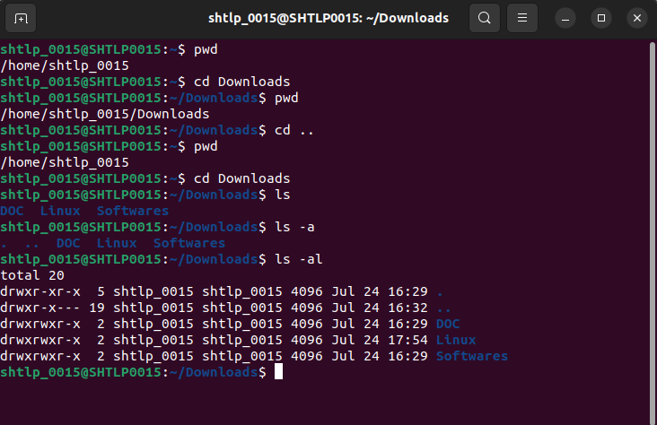
4. touch: Create a new empty file

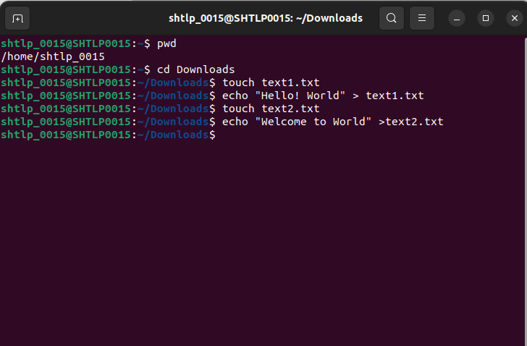
.
5. echo : can be used to create a file and add content to it

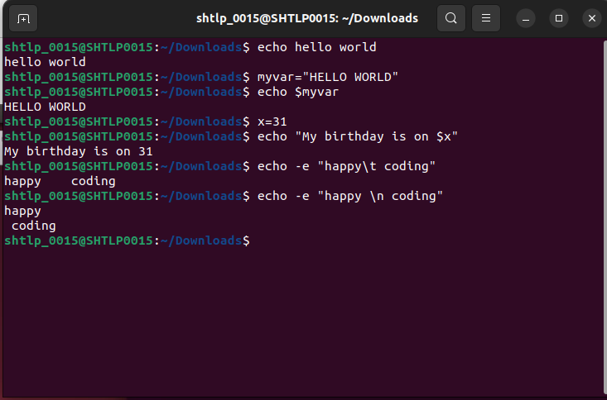
6. cat: display the entire content of file and can Concatinate and display the content of files and can also create file
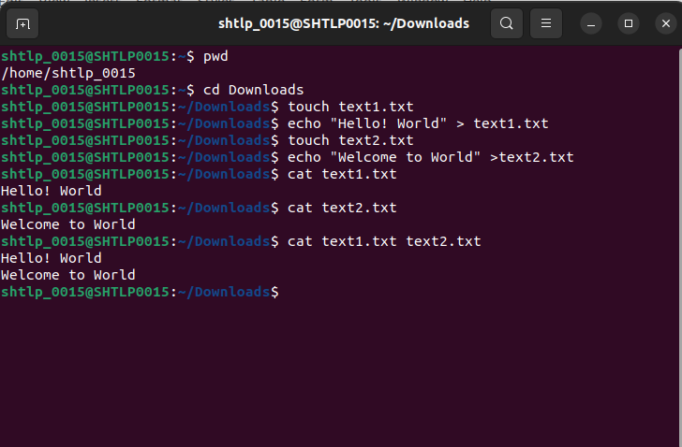
.
7. mkdir: create new directories
mkdir -p : create the entire pathi in one go
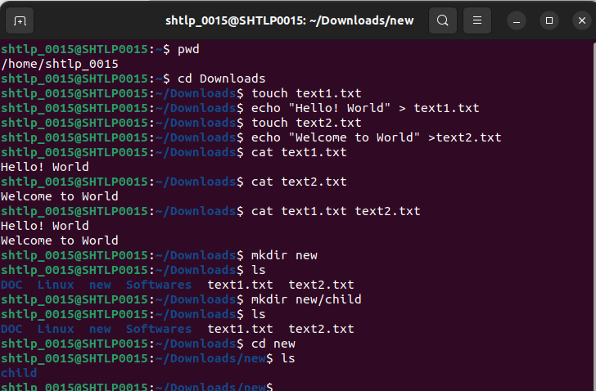

8. rmdir : removes directories that do not contain any subdirectories
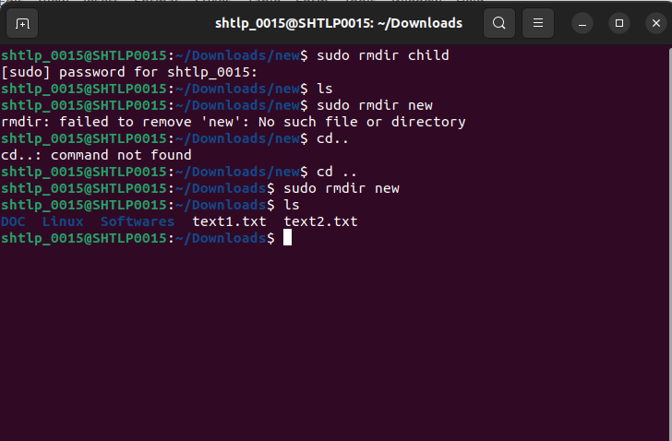
.
9. sudo : “Super User Do” allows authorized user to execute command with elevated privalge
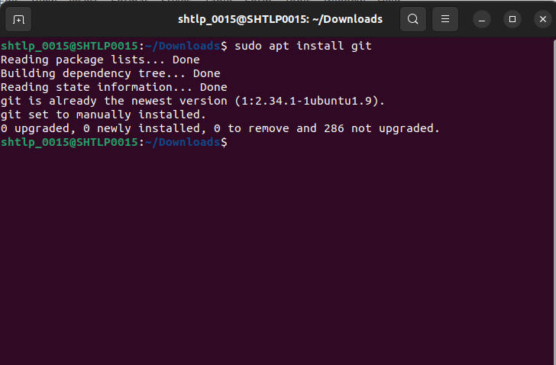
.
10. cp: copy files or directory
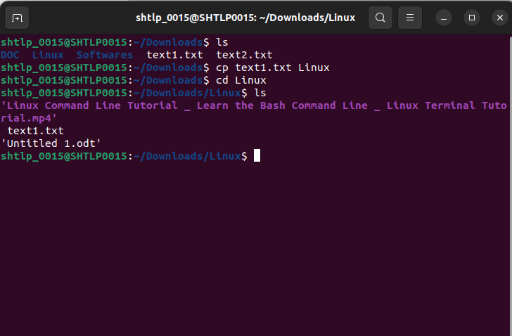
.

11.kill: Terminate process by sending Signal
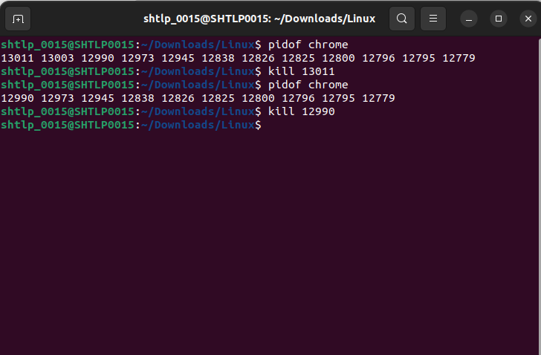
.

12. df: display disk usage

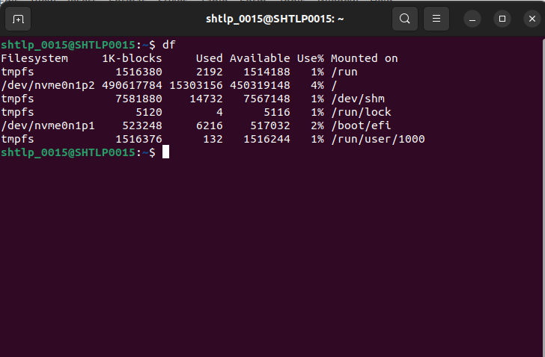
.

13. I/O Redirection :
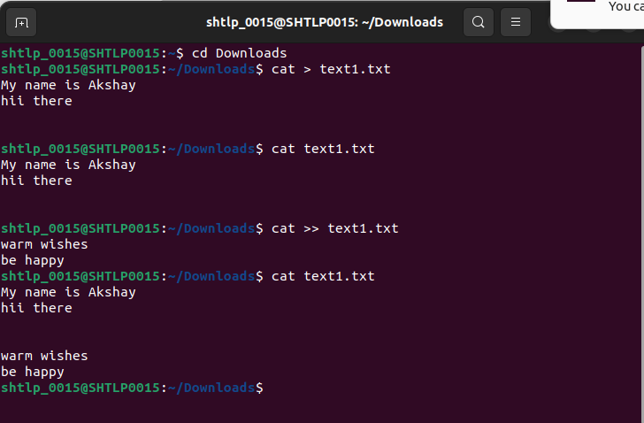
.
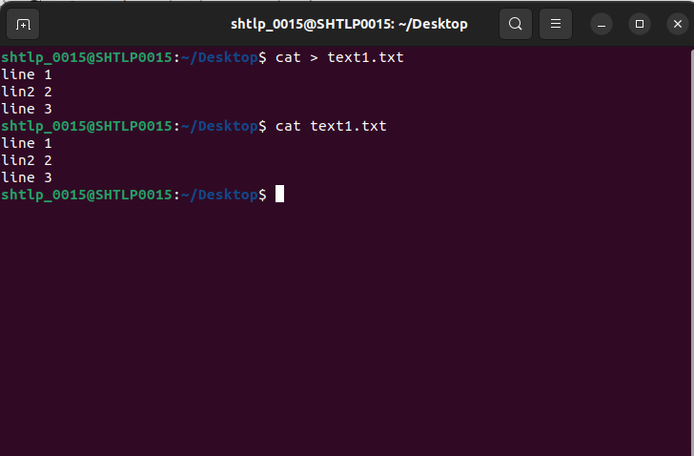
.

14. mv : rename file name and move file to stated directory
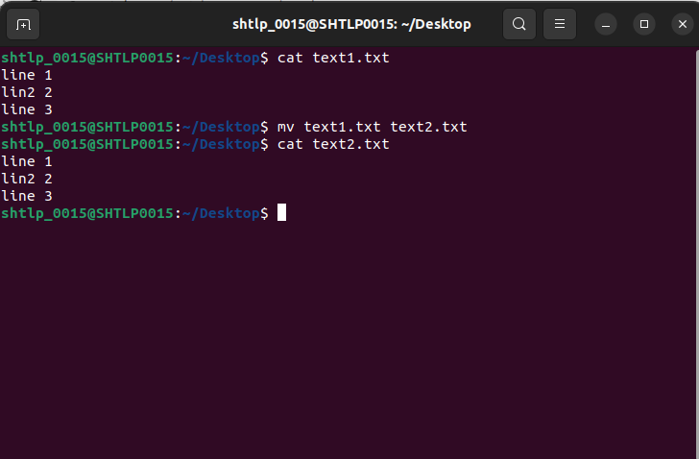

15. less- shows a file's contents one screen at a time.



